**Assignment 1**

(Weight 3%)

Bandana Pachabhaiya Magar (C0916126)

## **Question # 1 : P02-01- Jenny's Salon & Spa**

* Create a file called P02-01
* Design the data models below
* Export the file containing the data models as a PDF file and submit

1. At Jenny's Salon & Spa, we have several hairstylists that are salaried employees. In addition to their salary, we store their first name, last name, social security number, mobile number, and email address. The salon has clients, which they record first name, last name, mobile number, email address, and preferred day. Some clients do not have a preferred day.

* Name the first tab P02-01a

1. Identify and draw the entities
2. Add the attributes associated with each entity and identify them as mandatory or optional
3. Identify candidate keys for each entity

* Specify the UID/PK for each entity
* Specify all other candidate keys as unique keys (UKs)

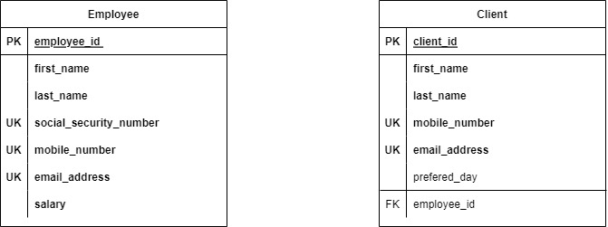

Fig: P02-01a

**B)** Each hairstylist is assigned clients. When a hairstylist is hired, the hairstylist is not assigned

any clients during orientation. Each client is asked if they have a preferred hairstylist. If they

have no preference, they are assigned a hairstylist that becomes their hairstylist. Of course,

they can switch to another hairstylist at any time.

* Name the second tab P02-01b

1. Include relationships and ER language

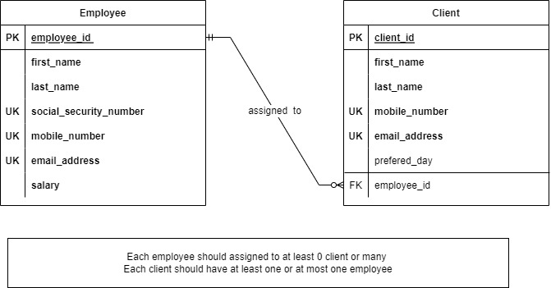

Fig: P02-01b